**IT Institution Course Management System**

The IT Institution Course Management System is a web-based application designed to facilitate the management of courses offered by an IT training institution. Built using JavaScript, HTML, and CSS, this system provides a comprehensive platform for administrators to efficiently manage student enrollments, course offerings, fee collections, and payment plans. The primary goal of this project is to streamline course management processes and enhance the learning experience through effective use of modern web technologies.

**Key Features**

# 1. Student Registration

* **NIC Number Registration:** ~~Students~~ {admins} are required to register [students] with their National Identity Card (NIC) number. This ensures a unique identifier for each student, simplifying the process of tracking student information and payment history.
* **User Profile Management:** Students can view and update their personal information, including contact details and enrolled courses.

# 2. Course Offerings

* **Course Categories:** Courses are categorized based on programming languages such as Java, C#, C++, Python, and proficiency levels (beginner, intermediate).
* **Course Duration:** Courses span from 2 months to 6 months, depending on the complexity and depth of the programming language.

# 3. Fee Management

* **Initial Registration Fee:** Upon enrollment, students may be required to pay an initial registration fee. The system tracks this payment and ensures that only registered students can access course materials and participate in classes.
* **Payment Plans:** Fees can be paid in one lump sum or divided into installments based on the duration of the course. The system manages payment schedules and alerts students about upcoming payments.
* **Fee Collection:** Administrators can track fee payments, generate invoices, and manage financial transactions securely through the system.

# 4. Alerts and Notifications

* **Payment Reminders:** The system sends notifications to students regarding upcoming fee due dates and installment payments. This ensures that students are informed and can plan their payments effectively.
* **Course Progress Updates:** Students receive updates on course schedules, assignments, and assessments through notifications, enhancing their engagement and participation.

# 5. Reports

* **Student Report:** Provides a detailed overview of all enrolled students, including their course selections, payment status, and contact information.
* **Course Enrollment Report:** Tracks enrollment statistics for each course category and proficiency level, helping administrators to optimize course offerings based on demand.
* **Financial Report:** Generates financial summaries, including revenue generated from course fees, outstanding payments, and overall financial health of the institution.

**User Roles**

# 1. Administrator

* Manage student registrations (add, update, remove).
* Create and manage course offerings.
* Monitor fee collections and manage payment plans.
* Generate and view reports on student enrollments and financial transactions.

# 2. Student

* ~~Register and~~  {Only} manage their profile.
* Enroll in courses based on their interests and career goals.
* Pay course fees and manage payment schedules.
* Receive alerts and notifications related to course progress and fee payments.

# Technical Overview

The IT Institution Course Management System is developed using JavaScript, HTML, and CSS. To ensure simplicity and ease of use, the system is designed to work entirely on the client side, utilizing local storage for data persistence. This approach eliminates the need for a server-side backend, making it ideal for small to medium-sized training institutions.

* **JavaScript:** Manages the core functionality, including event handling, DOM manipulation, and interaction with local storage. JavaScript is used to perform operations such as student registration, course enrollment, fee calculation, and payment tracking.
* **HTML:** Structures the content and elements of the web pages.
* **CSS:** Enhances the appearance and layout, providing a consistent and user-friendly design across different devices and screen sizes.
* **Local Storage:** Utilized for data persistence, local storage ensures that all data (students, courses, payments) is saved directly in the user's browser. This enables the application to retain data between sessions without requiring a server-side database.

# Conclusion

The IT Institution Course Management System offers a robust solution for managing the diverse needs of an IT training institution. By integrating essential features such as student registration, course management, and fee collection, it simplifies the administrative tasks for administrators while providing a seamless learning experience for students. The addition of comprehensive reporting capabilities enhances the system's utility by providing valuable insights into student enrollments, course popularity, and financial performance. This project represents a significant step towards digitizing course management and improving the overall efficiency and accessibility of educational services in the IT domain.

Finished

1. Admin Role
   1. Admin can register students and remove students
   2. Admin can view each students details and update details
   3. Admin can add new course, update course, remove course
2. Student Role
   1. View all courses
   2. View personal details
3. Admin Role
   1. Report
   2. Notification
4. Student Role
   1. Select courses
   2. Payments
   3. Notification and alerts

Please open data file first

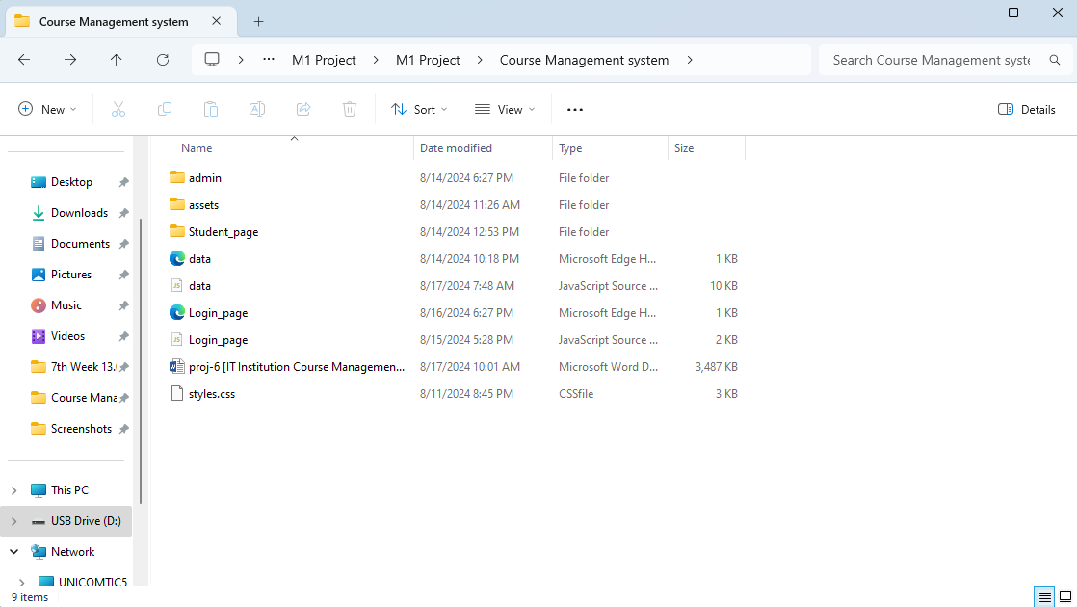

**localStorage data structure**

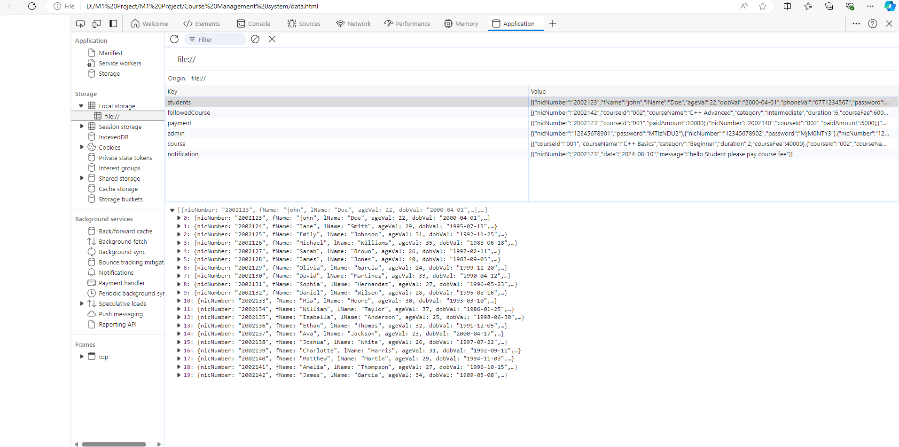

Admin and student are login same page

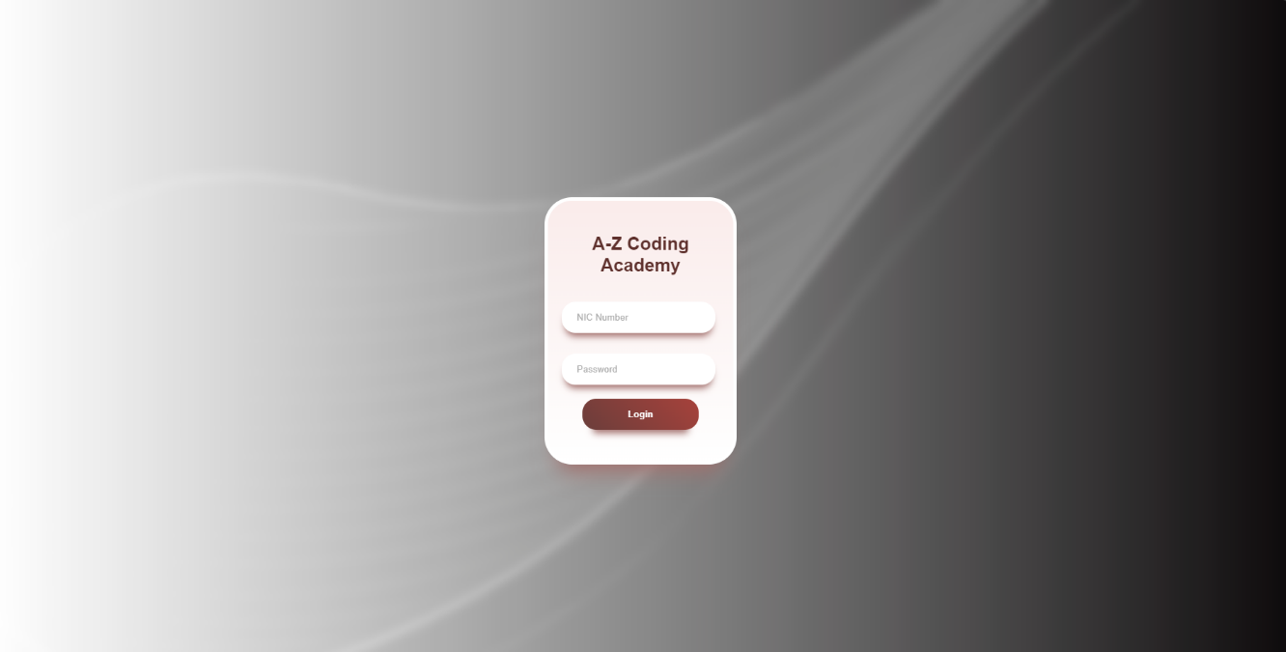

Admin data >

|  |  |
| --- | --- |
| NIC Number | Password |
| 12345678901 | 123456 |

Student sample data >

|  |  |
| --- | --- |
| NIC Number | Password |
| 2002123 | 123456 |
| 2002124 | 123456 |

**Login ADMIN**

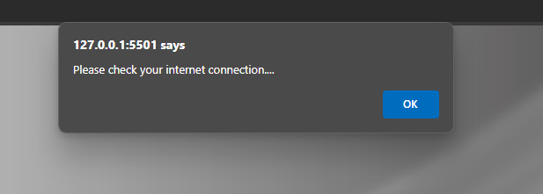

Home

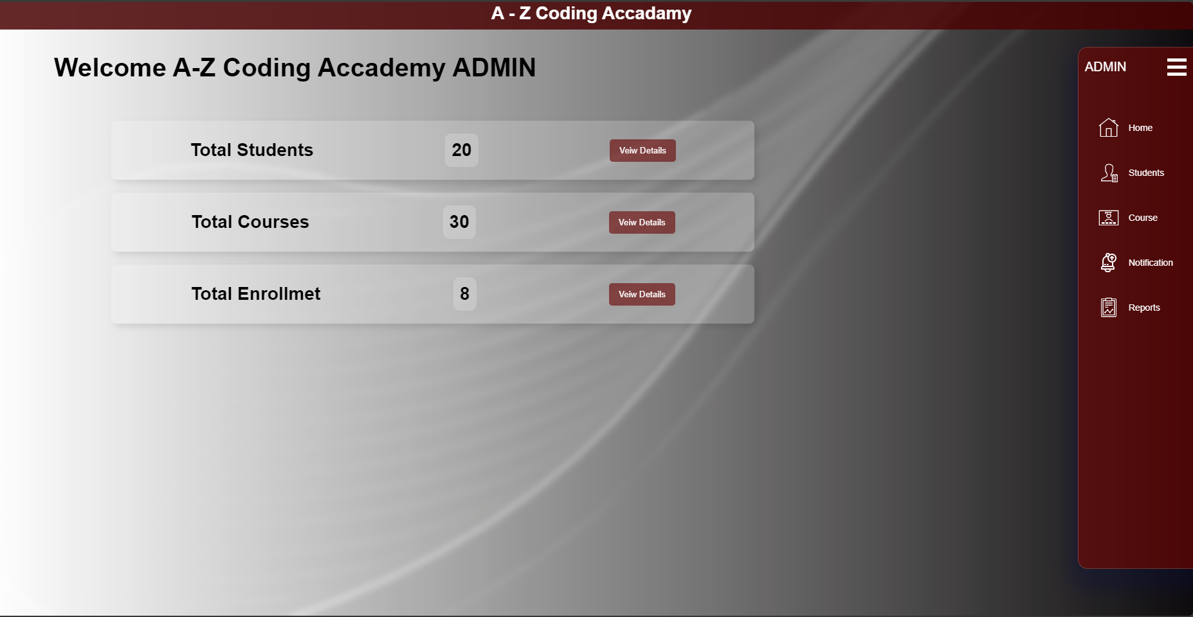

Navigation Students

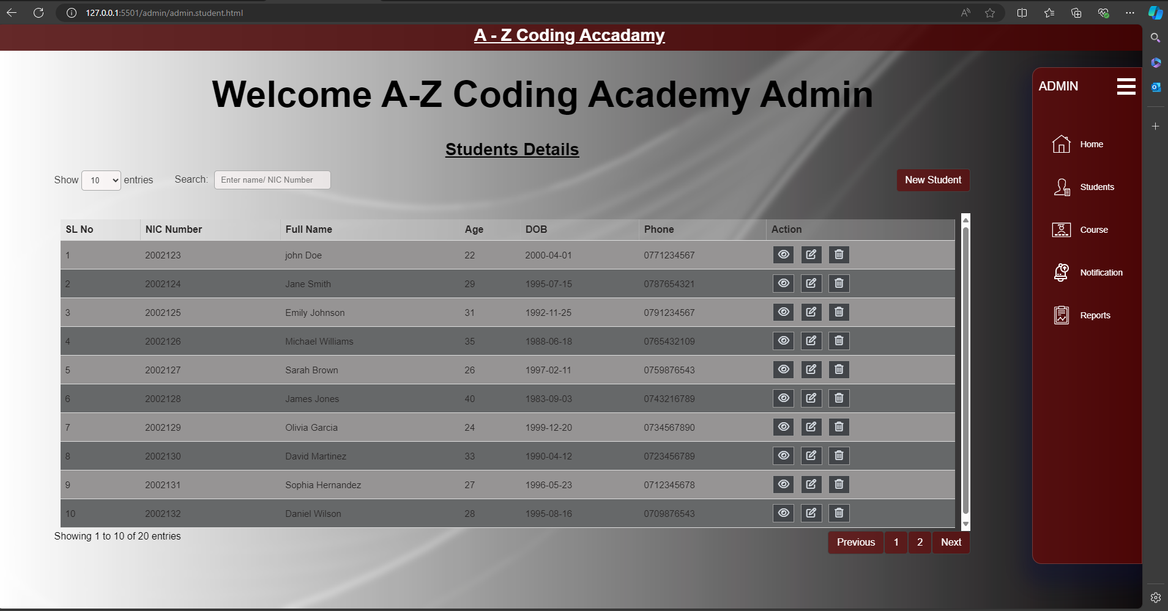

* Can search by NIC Number or Name
* Cant register if student already register(window alert)

Students New Students

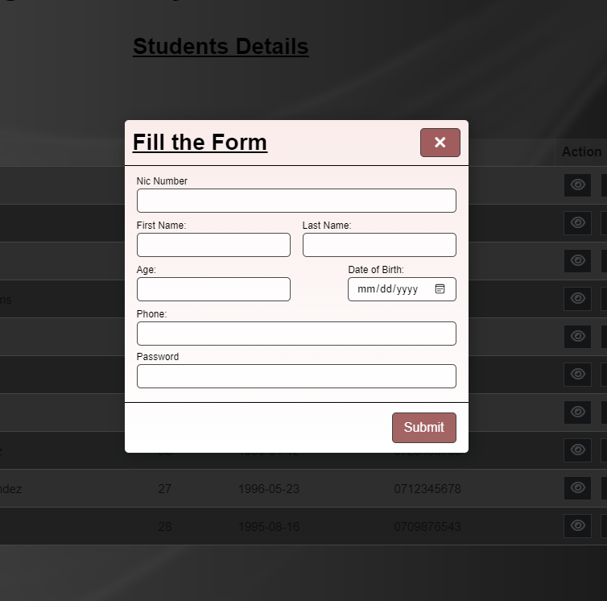

Navigation Course

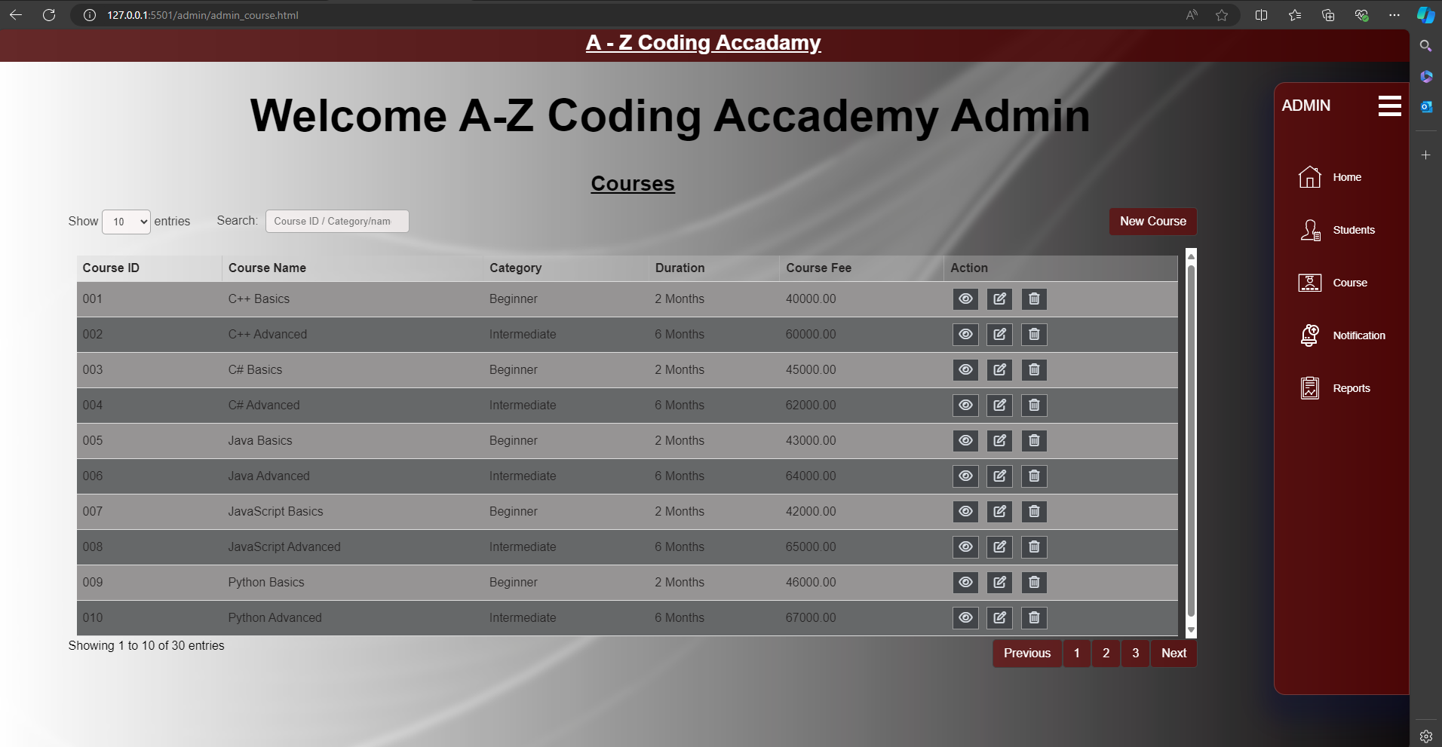

* Can search Name and Catogary

Students New course

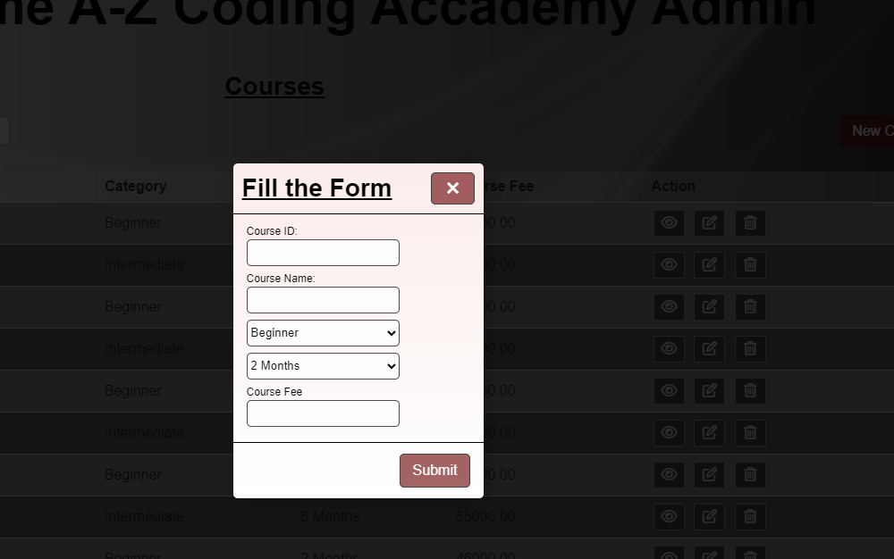

Navigation Notification

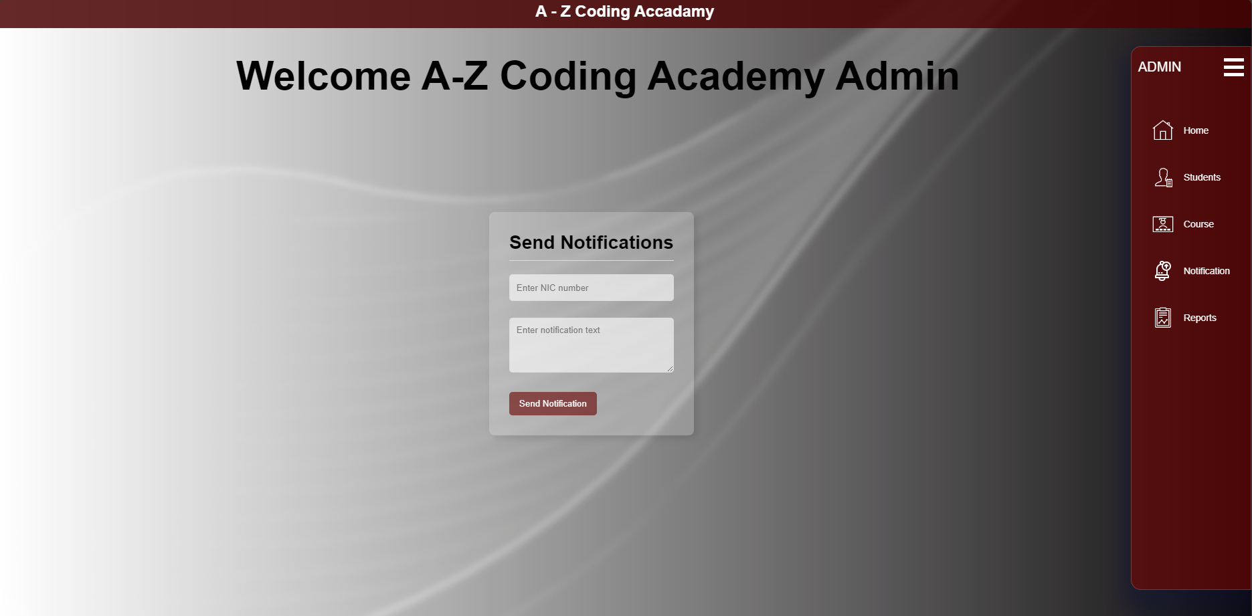

* Admin can send notification by Student NIC Number

Navigation Report

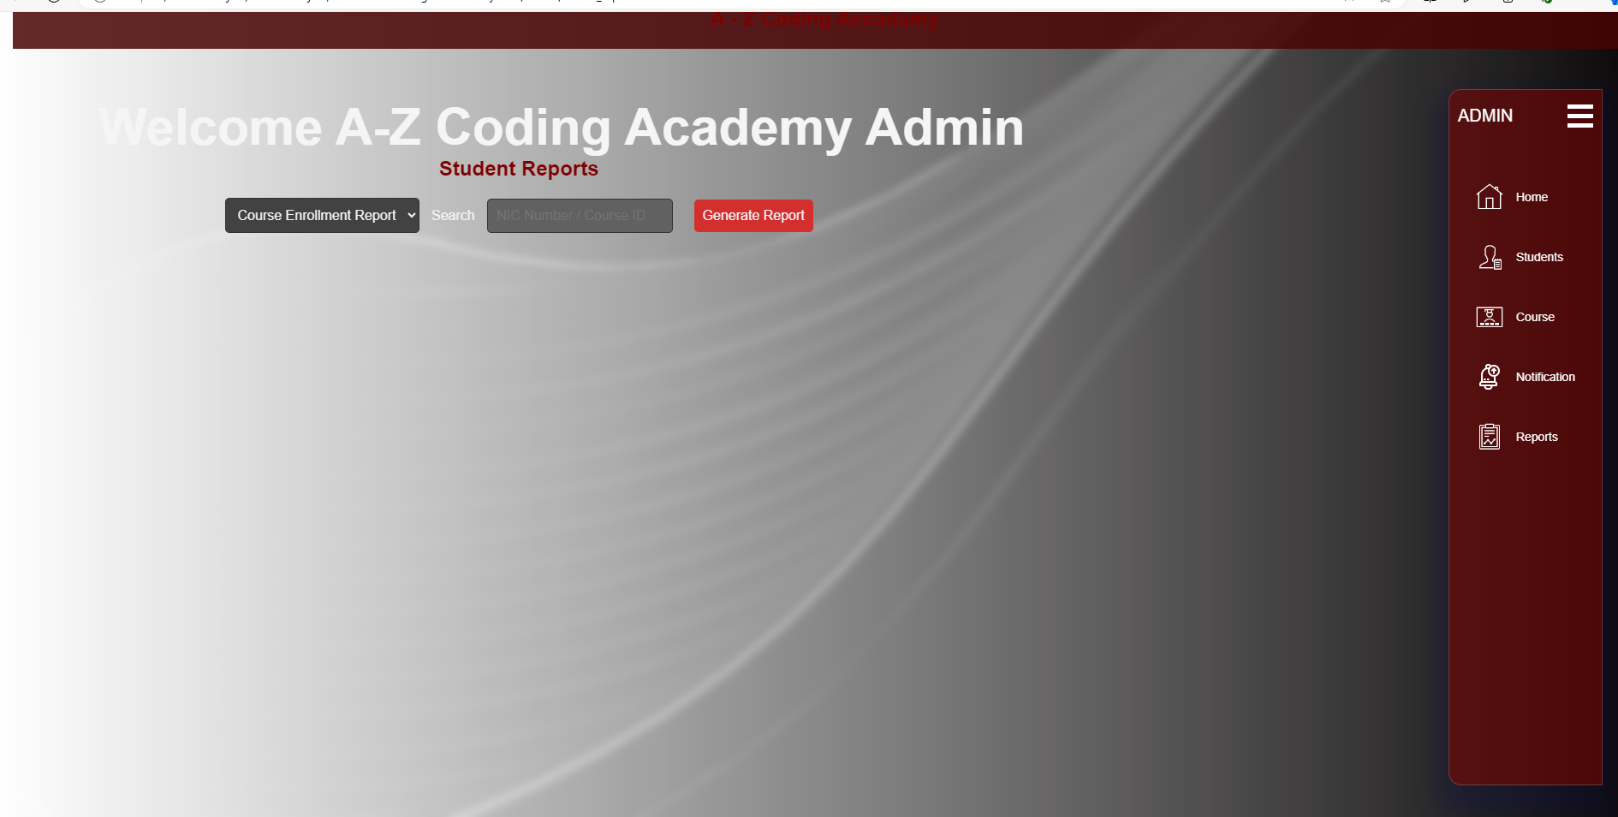

* Course enrolment report finished
* Payment report 80% complete
* Report can generate with NIC Number and Course ID

**Login Students**

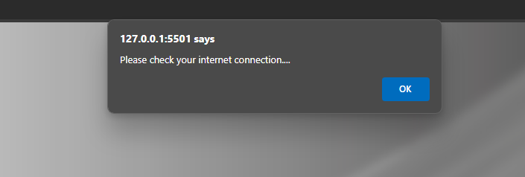

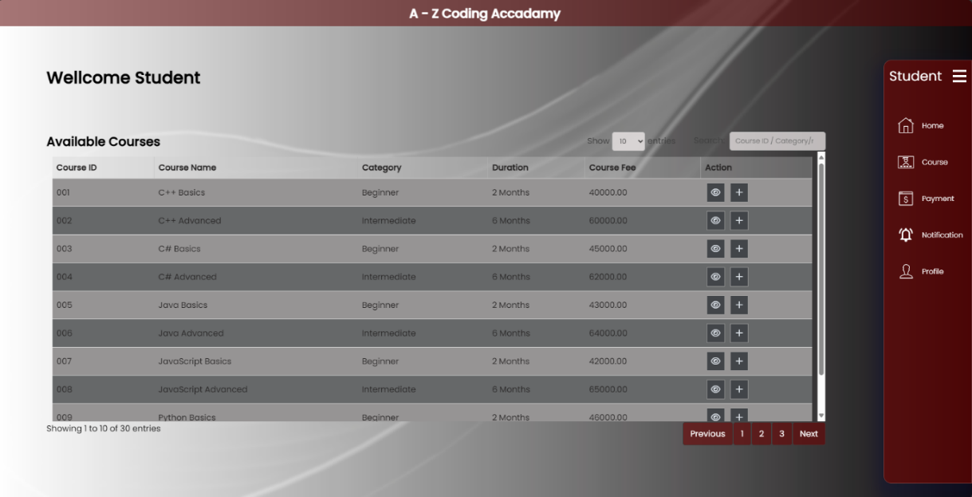

If click eye button

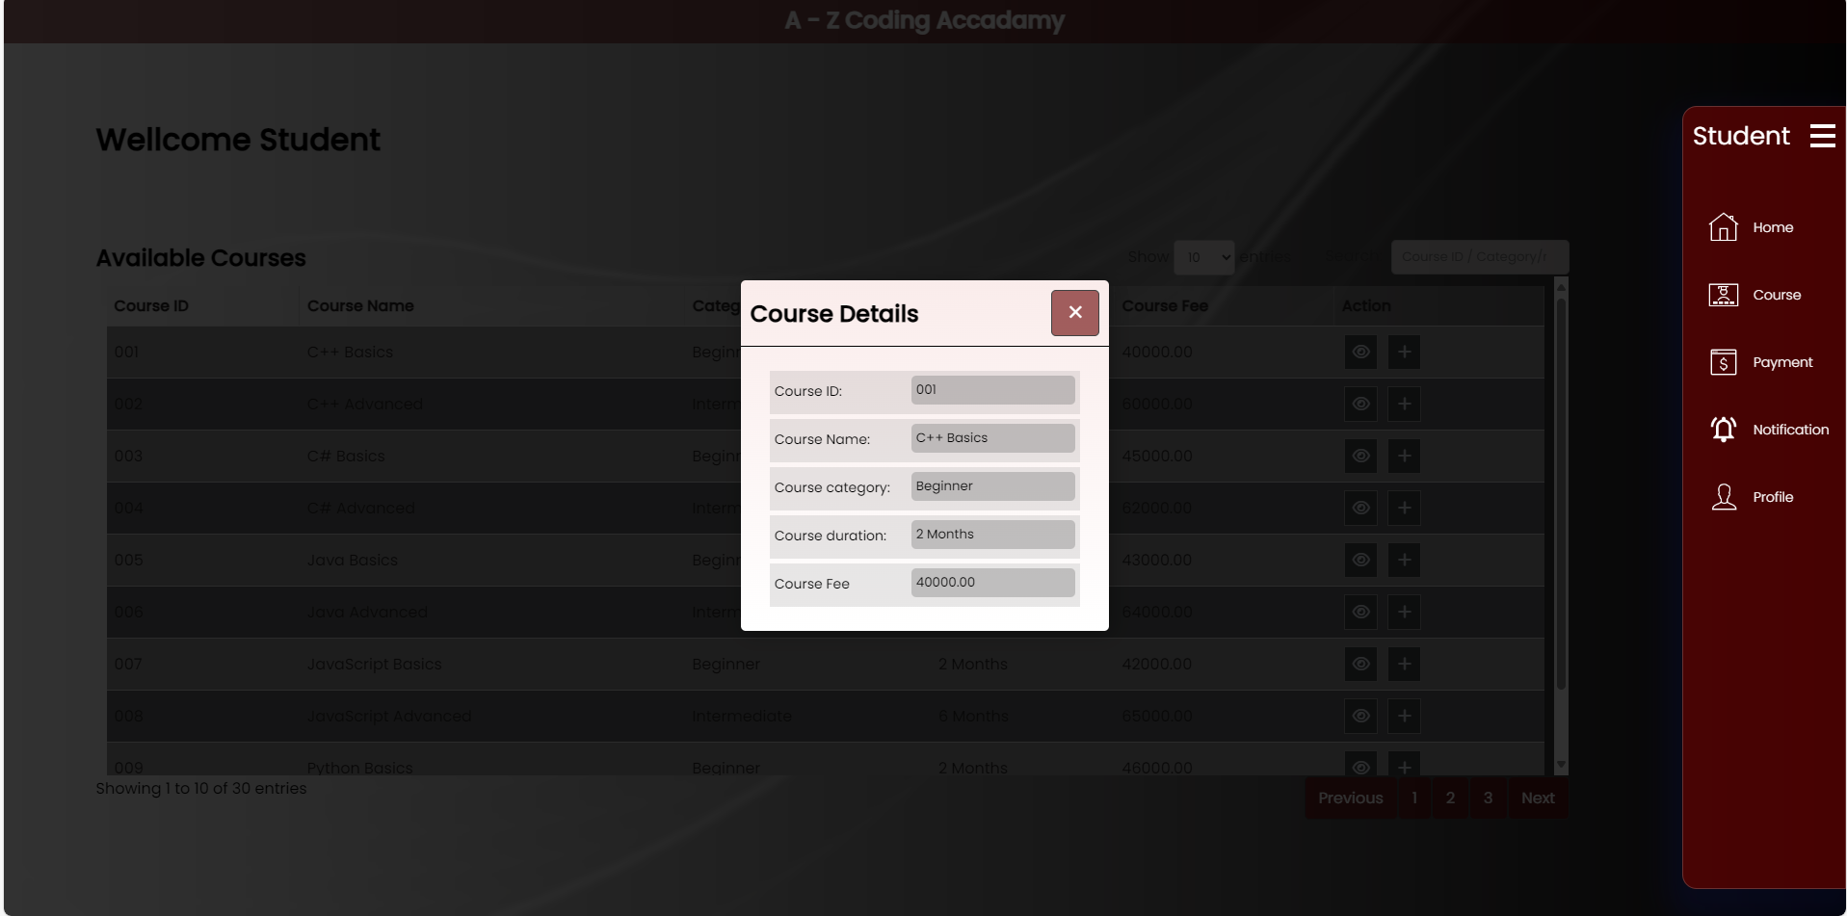

If click follow button =

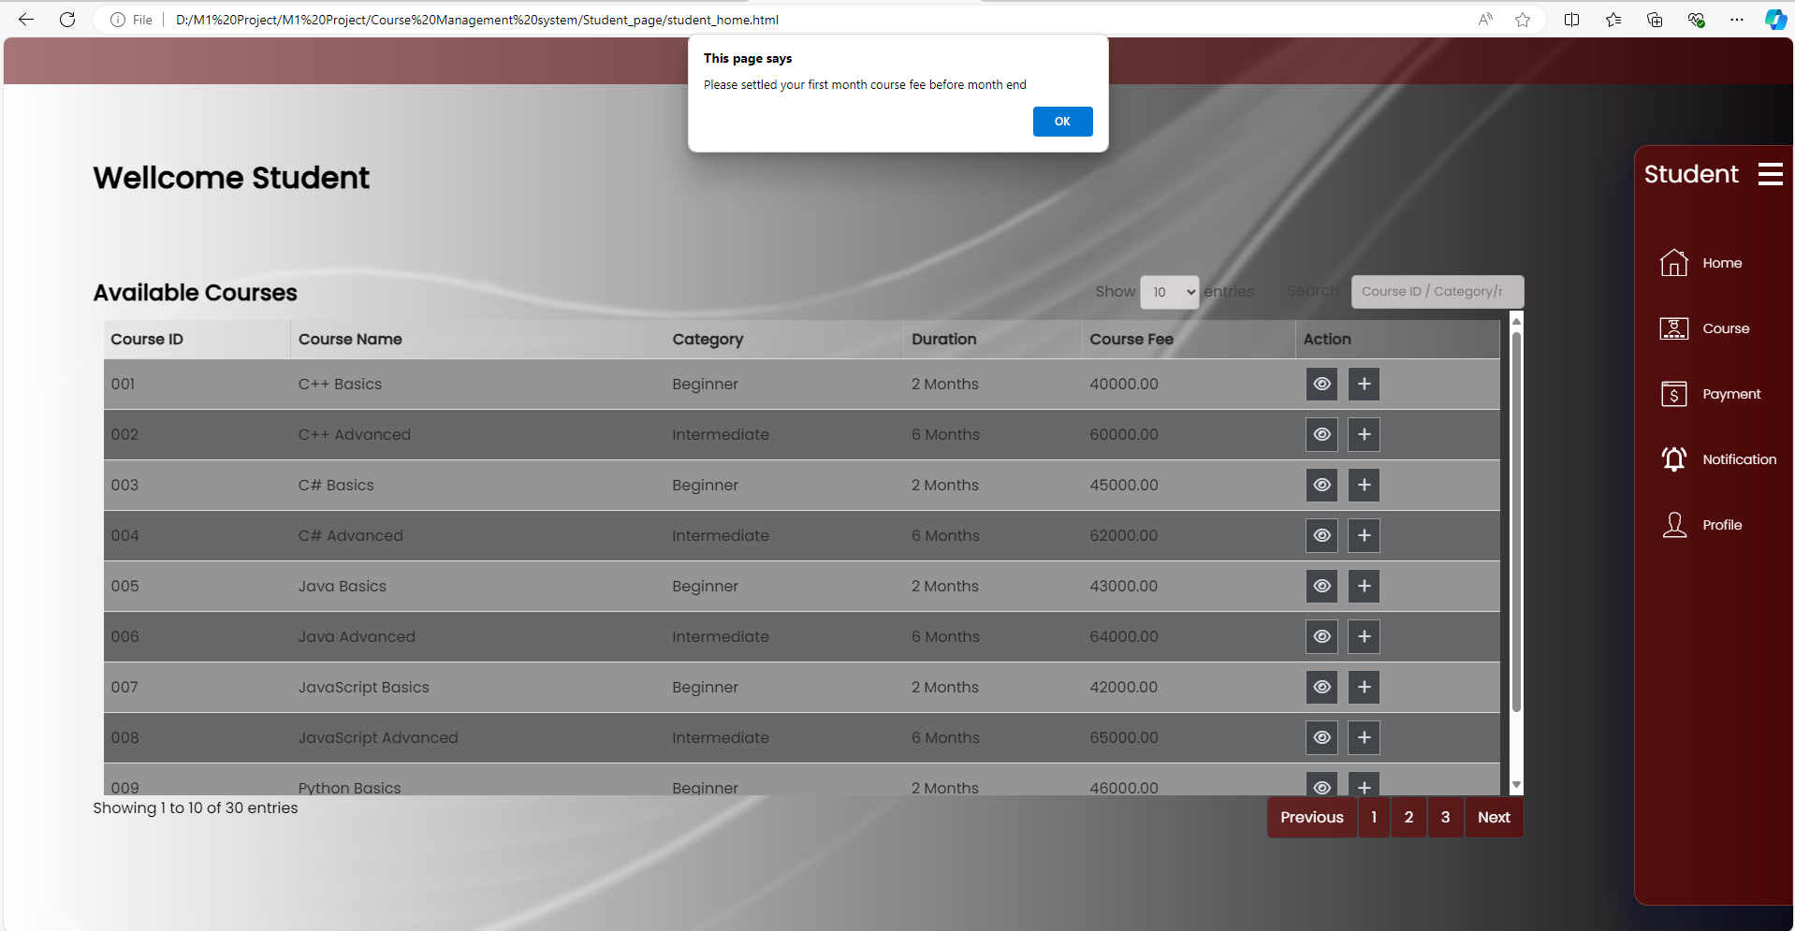

* Student can view available course details
* Student can follow course
* If student already follow course cant follow again (window alert)
* If student will follow course will come window alert

Navigation Course

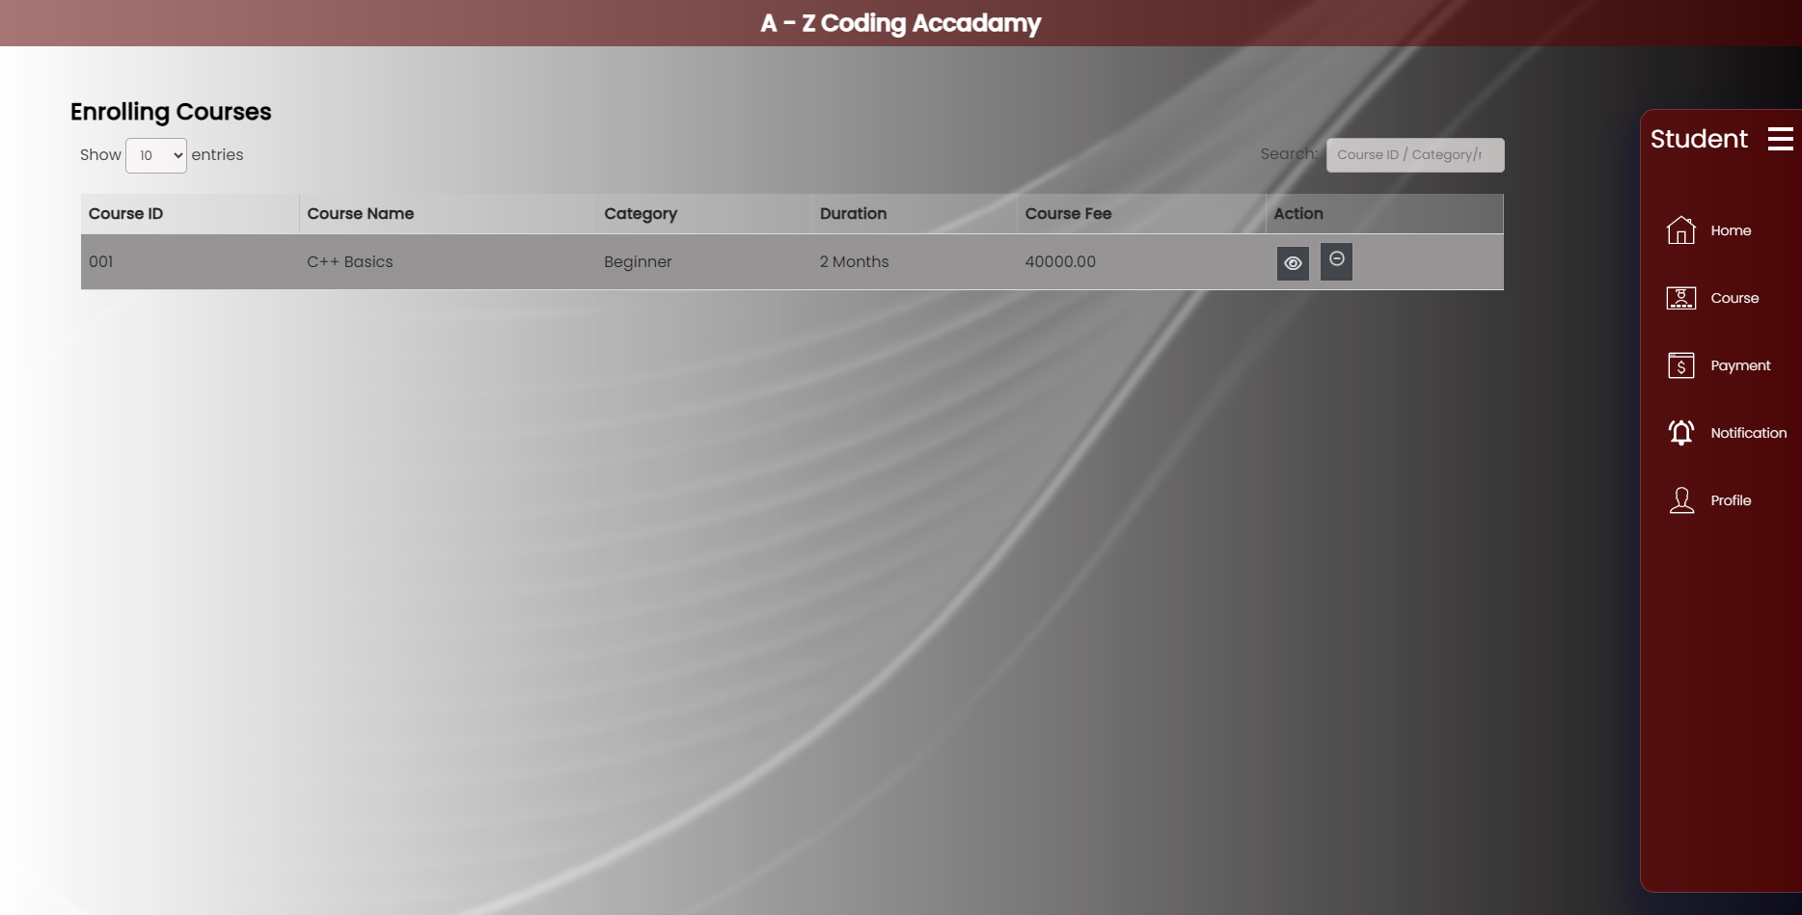

Navigation Payment

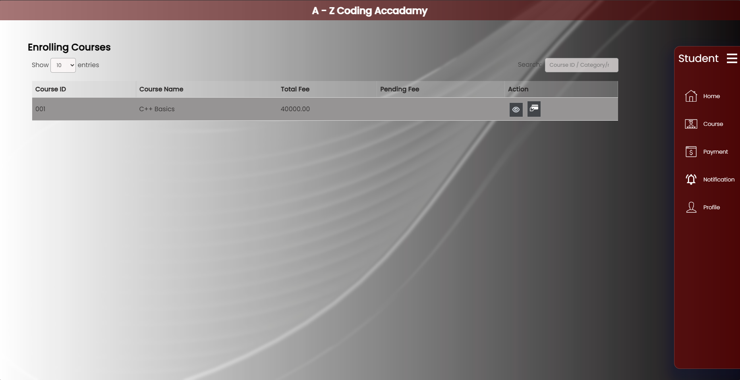

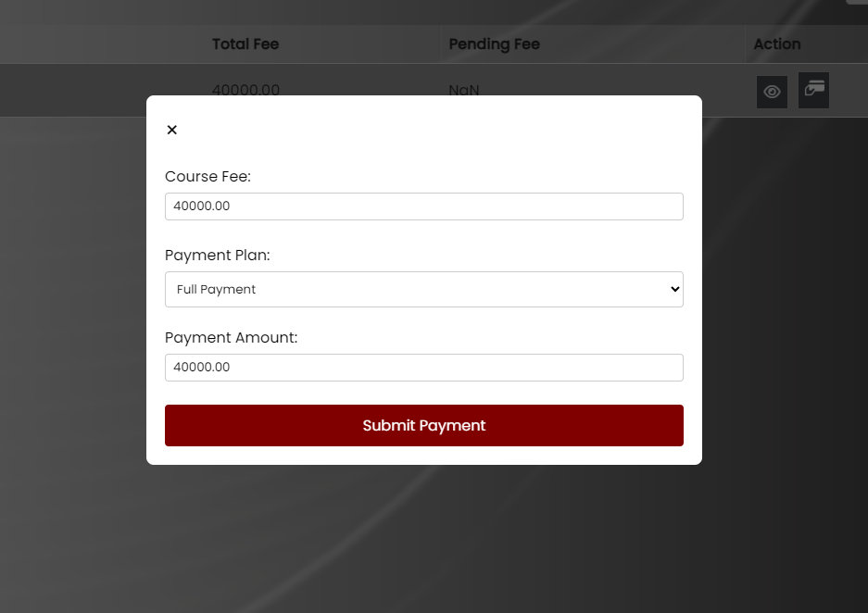

* Student can make payment
* Student can choose payment plan

Navigation Notification

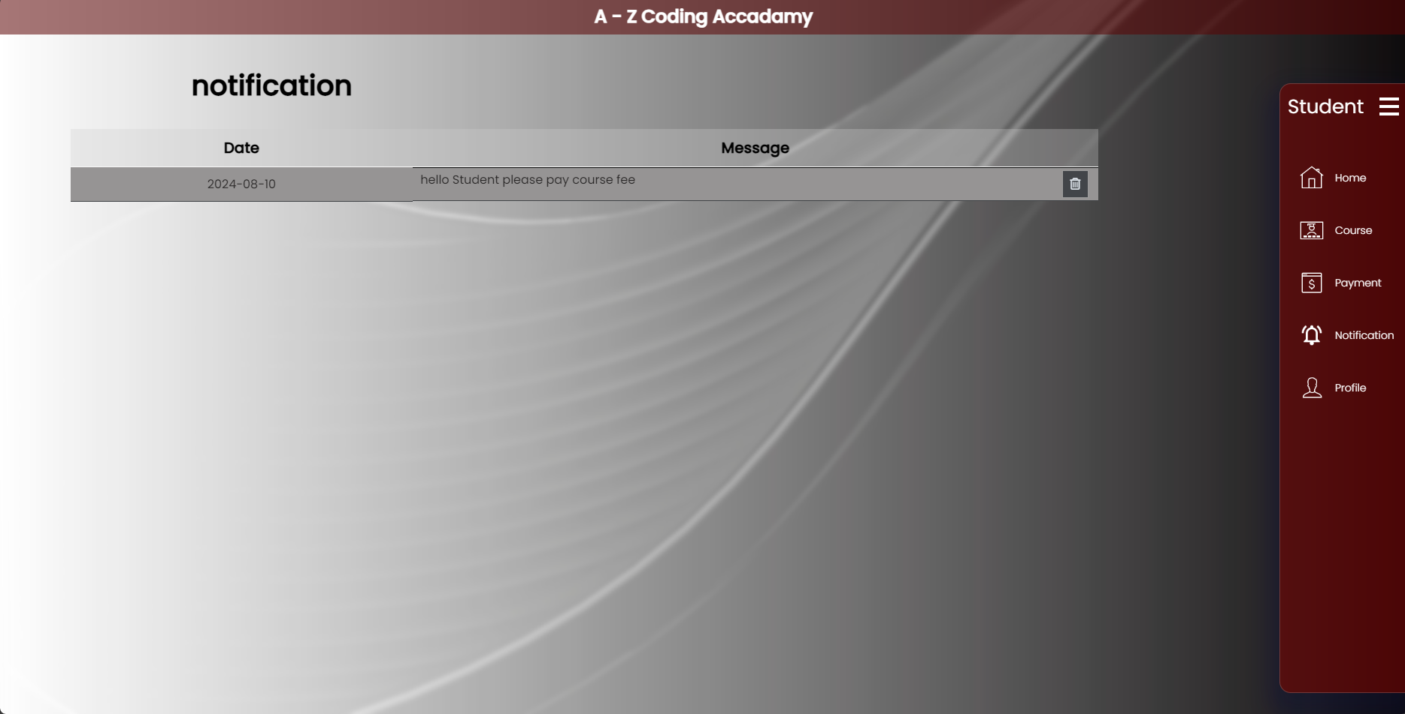

* Student can view notifications
* Student can delete notifications

Navigation Profile

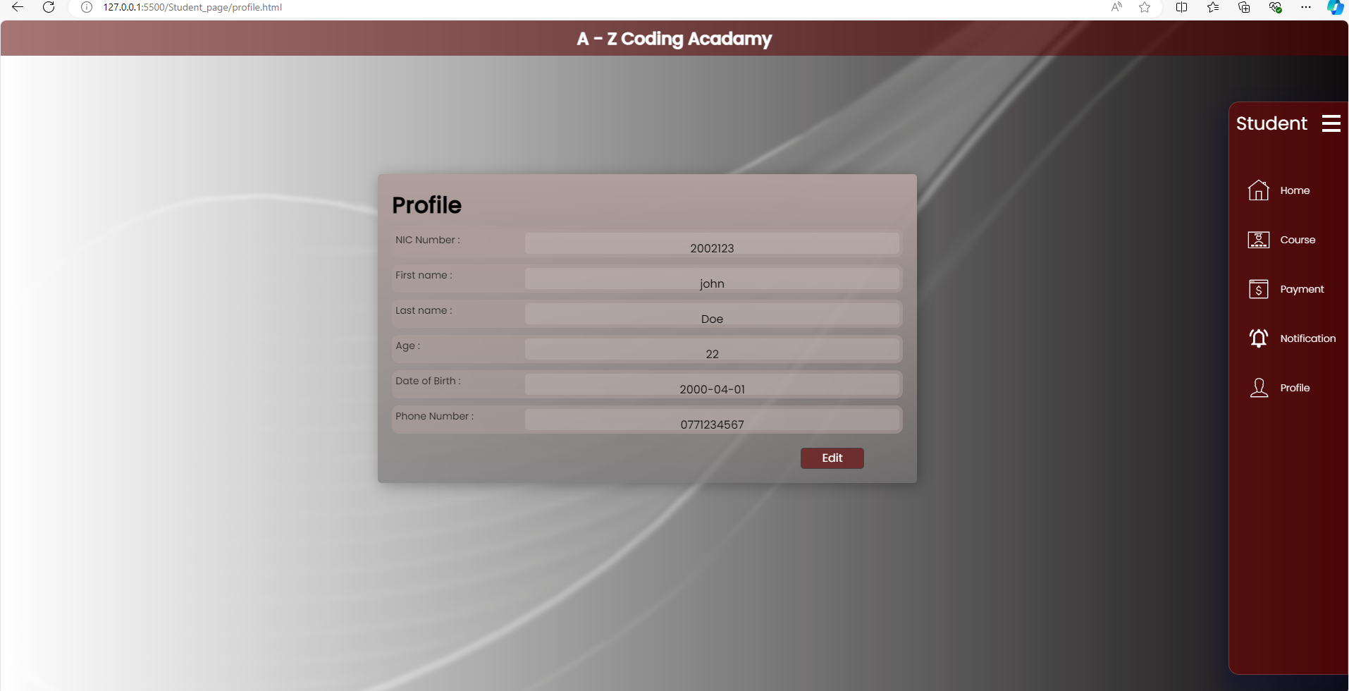

Edit details

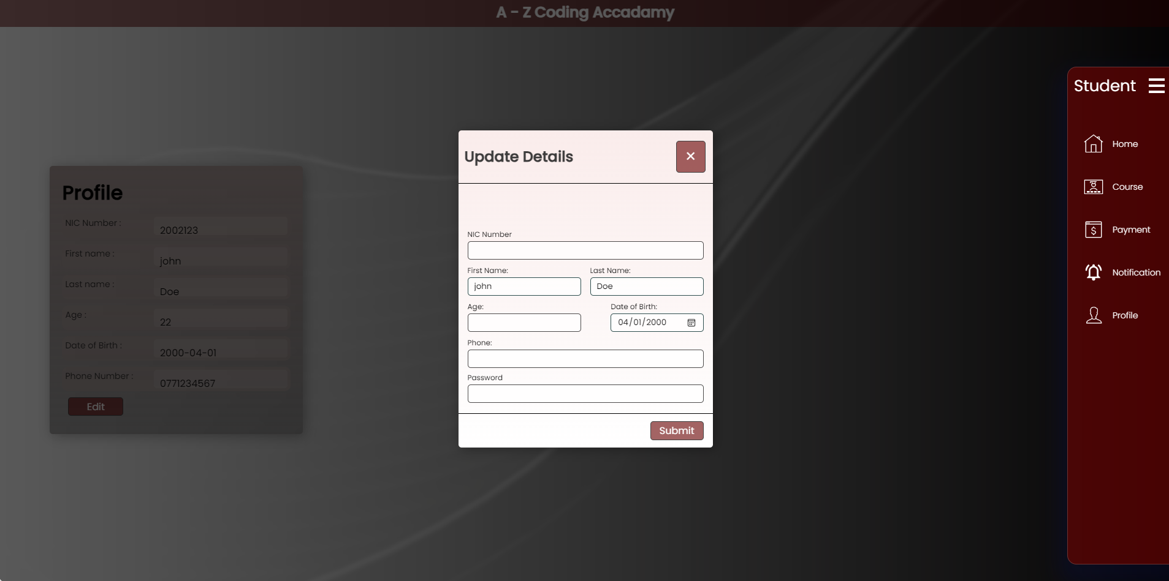

* Student can view their details
* Student can update and change their personal details (cant change NIC Number)
* Student can change their Password